# Staff Declaration of Interests Form

*Please see notes on page 2 for information on how to populate the boxes.*

|  |  |  |  |  |  |
| --- | --- | --- | --- | --- | --- |
| **Name** | **Role** | **Description of Interest** | **Relevant dates** | | **Comments** |
| From | To |
|  |  |  |  |  |  |
|  |  |  |  |  |  |
|  |  |  |  |  |  |
|  |  |  |  |  |  |
|  |  |  |  |  |  |
|  |  |  |  |  |  |
|  |  |  |  |  |  |
|  |  |  |  |  |  |
|  |  |  |  |  |  |
|  |  |  |  |  |  |
|  |  |  |  |  |  |
|  |  |  |  |  |  |
|  |  |  |  |  |  |

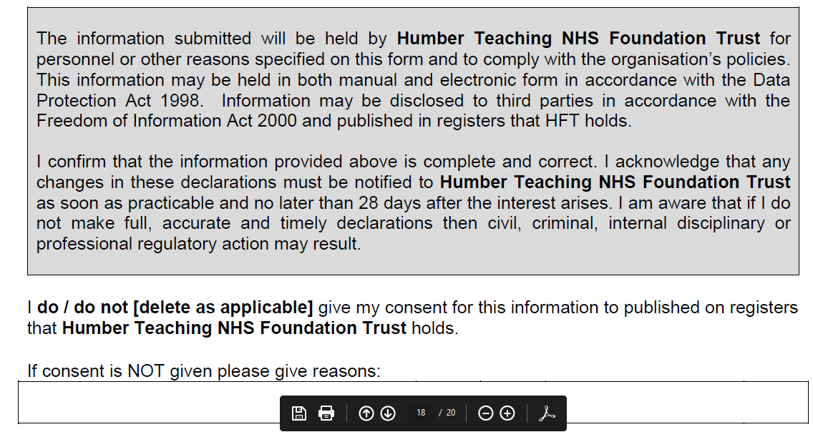

I **do / do not [delete as applicable]** give my consent for this information to be published on registers that Humber Teaching NHS Foundation Trust holds.

If consent is not given, please give reasons:

Signed:…………………………. Date:……………………………….



|  |
| --- |
| **GUIDANCE NOTES FOR COMPLETION OF INTERESTS DECLARATION FORM**  **Example of how to complete the form**    **Name and Role -** Insert your name and your position/role in relation to the Organisation you are making the return to  **Description of Interest -** Provide a description of the interest that is being declared. This should contain enough information to be meaningful (e.g. detailing the supplier of any gifts, hospitality, sponsorship, etc). That is, the information provided should enable a reasonable person with no prior knowledge should be able to read this and understand the nature of the interest.  **Financial interests** - This is where an individual may get direct financial benefits from the consequences of a decision they are involved in making |
| **Non-financial professional interests -** This is where an individual may obtain a non-financial professional benefit from the consequences of a decision they are involved in making, such as increasing their professional reputation or status or promoting their professional career |
| **Non-financial personal interests -** This is where an individual may benefit personally in ways which are not directly linked to their professional career and do not give rise to a direct financial benefit, because of decisions they are involved in making in their professional career |
| **Indirect interests -** This is where an individual has a close association with another individual who has a financial interest, a non-financial professional interest or a non-financial personal interest who would stand to benefit from a decision they are involved in making |
| A benefit may arise from both a gain or avoidance of a loss. |